

Student Name……………………………………

FURTHER MATHEMATICS

TRIAL EXAMINATION 1

2014

Reading Time: 15 minutes
Writing time: 1 hour 30 minutes

Instructions to students
This exam consists of Section A and Section B.
Section A contains 13 multiple-choice questions from the core, 'Data Analysis'.
Section A is compulsory and is worth 13 marks.
Section B consists of 6 modules each containing 9 multiple-choice questions. You should choose 3 of these modules and answer every question in each of your chosen modules.
Each of the modules is worth 9 marks.
Section B begins on page 9 of this exam.
There is a total of 40 marks available for this exam.
Unless otherwise stated the diagrams in this exam are not drawn to scale.
Students may bring one bound reference into the exam.
Students may bring into the exam one approved graphics calculator or approved CAS calculator or CAS software and, if desired, one scientific calculator. Calculator memory does not need to be cleared.
An answer sheet appears on page 38 of this exam.
A formula sheet can be found on pages 36 and 37 of this exam.

This paper has been prepared independently of the Victorian Curriculum and Assessment Authority to provide additional exam preparation for students. Although references have been reproduced with permission of the Victorian Curriculum and Assessment Authority, the publication is in no way connected with or endorsed by the Victorian Curriculum and Assessment Authority.

© THE HEFFERNAN GROUP 2014
This Trial Exam is licensed on a non transferable basis to the purchasing school. It may be copied by the school which has purchased it. This license does not permit distribution or copying of this Trial Exam by any other party.
SECTION A

Core: Data analysis

This section is compulsory.

Use the following information to answer Questions 1 and 2.

The box plot below shows the distribution of the time, in seconds, that Sarah spent on each of the previous 84 outgoing calls she made on her mobile phone.

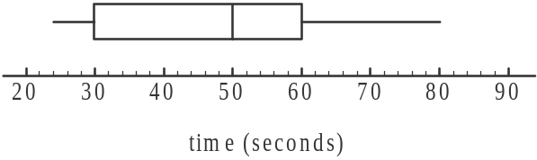

Question 1

The percentage of these outgoing calls that lasted for less than 60 seconds is

- 5%
- 50%
- 60%
- 63%
- 75%

Question 2

Which one of the following statements about these 84 outgoing calls that Sarah made, is not true?

- The longest call went for 80 seconds.
- Half of the calls were between 30 and 60 seconds long.
- More than half the calls were longer than 40 seconds.
- More than half the calls were shorter than 45 seconds.
- The median call time was 50 seconds.

Question 3

The histogram below shows the distribution of the total time worked, in hours, by 75 casual employees at a supermarket, during a particular week.

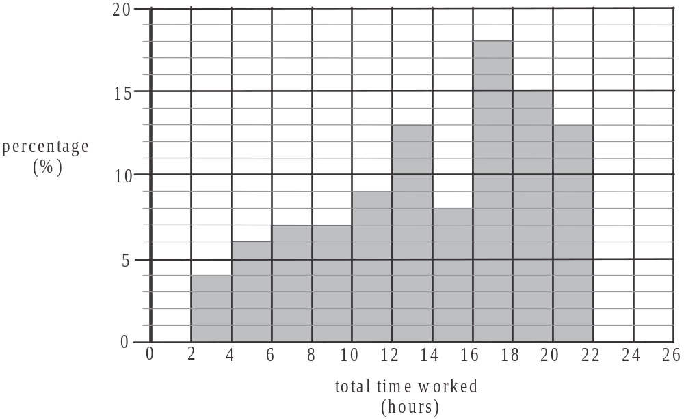

During this particular week, the number of these 75 casual employees who worked between 8 and 12 hours was

- 5
- 7
- 8
- 12
- 16
Question 4

The two forms of assessment used for a university commerce subject are an assignment and an exam. Each form of assessment is marked out of 100.
The mean and standard deviation for both forms of assessment for the 2013 students taking the subject are shown in the table below.

 | Form of assessment
 | Assignment | Exam
subject mean | 72 | 57
subject standard deviation | 8 | 12

The marks for both forms are approximately normally distributed.
A student gained 92 on their assignment.
In order to obtain the same standard score for both forms of assessment, this student needed to obtain a score on their exam of

- 69
- 77
- 87
- 91
- 97

Question 5

The weight, in grams, of packets of a certain type of chocolate biscuit is normally distributed with a mean of 320g and a standard deviation of 3 grams.
A supermarket takes delivery of 800 of these packets of biscuits. The number of them that weigh less than 314g is

- 20
- 40
- 34
- 128
- 200

Use the following information to answer Questions 6 and 7.

The table below shows the BMI (body mass index) for a group of 12 army recruits before and after their basic training.

 | BMI
Recruit | Before | After
1 | 26 | 23
2 | 21 | 19
3 | 19 | 18
4 | 23 | 22
5 | 27 | 26
6 | 24 | 21
7 | 25 | 23
8 | 29 | 26
9 | 26 | 21
10 | 22 | 20
11 | 20 | 18
12 | 19 | 16

Question 6

The mean and standard deviation, correct to one decimal place, of the recruit’s BMI after basic training are given respectively by

- 20.9 and 3.0
- 21.1 and 3.1
- 22.5 ad 3.2
- 23.4 and 3.3
- 24.3 and 3.0

Question 7

If the after BMI is taken as the dependent variable and the before BMI is taken as the independent variable then the equation of the least squares regression line is closest to

- 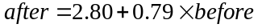
- 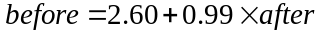
- 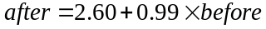
- 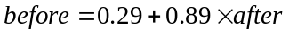
- 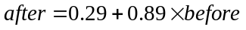
Question 8

At a cinema complex, the correlation coefficient r, between audience numbers and ticket prices is - 0.697 and the correlation coefficient r, between the number of staff working at the complex and the ticket prices is 0.514. Using this information, which one of the following statements can be true?

- The slope of a 3-median regression line relating the number of staff working at the complex and ticket prices is negative.
- There is a stronger association between the number of staff working at the complex and ticket prices than between audience numbers and ticket prices.
- As ticket prices increase, the number of staff working at the complex decreases.
- Audience numbers tend to decrease as ticket prices increase.
- Approximately 26.4% of the variation in the audience numbers can be explained by the variation in ticket prices.

Question 9

The scatterplot below shows the weight loss, in kg, of a group of women together with the number of weeks they have been following a particular diet.
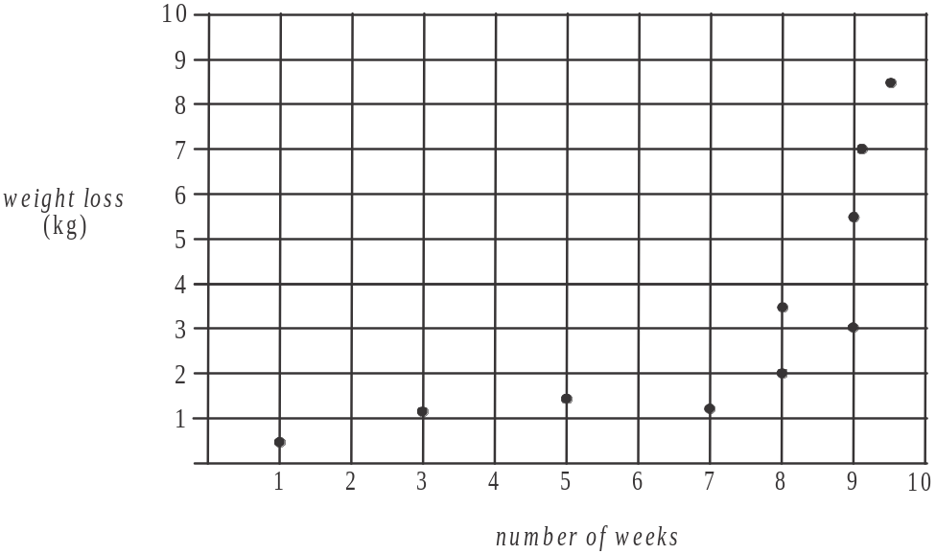

The scatterplot is non-linear.
In an effort to linearise the data, 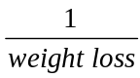 is plotted against number of weeks.
A least squares regression line is fitted to this transformed data. Its equation is given by

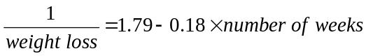.
According to this equation, a woman who followed the diet for 6 weeks would have a weight loss in kg that is closest to

- 0.7
- 1.4
- 2.9
- 3.6
- 9.8
Question 10

For a set of linearly related bivariate data involving the variable length (in cm) and the dependant variable weight (in g), the following statistics have been calculated.

Statistic | length (x) | weight (y)
mean |  | 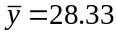
standard deviation | 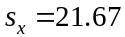 | 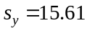
correlation coefficient

The equation of the least squares regression line for the weight in terms of length is given by

- 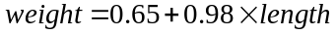
- 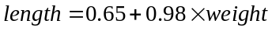
- 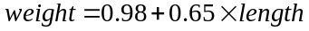
- 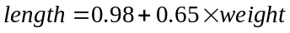
- 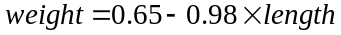

Question 11

The time series plot below shows the annual costs for a small business between 2001 and 2009.
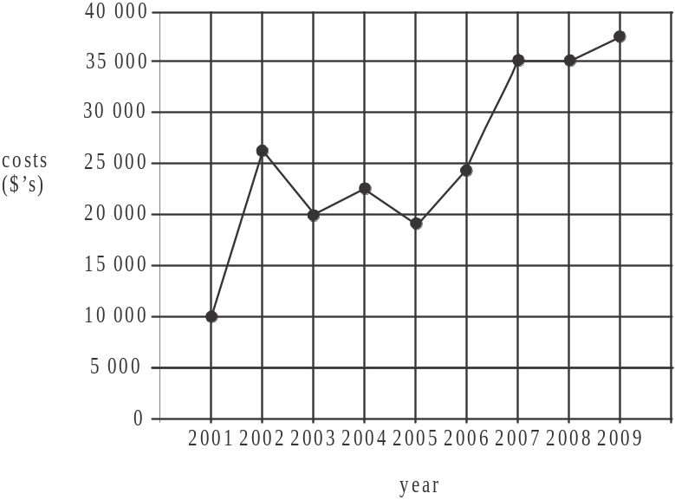

If a 3- median regression line was fitted to this data it would show that on average the annual costs have increased each year by

- $1 667
- $2 000
- $2 500
- $2 917
- $3 333
Question 12

The number of day procedures carried out at a rural hospital each month during 2012 is displayed in the table below.
Month | Number of day procedures
January | 4
February | 15
March | 27
April | 42
May | 37
June | 16
July | 9
August | 23
September | 38
October | 48
November | 36
December | 12
When four-mean smoothing with centring is applied to this data, the smoothed number of day procedures in August is closest to

- 21.5
- 25.5
- 26.8
- 27.8
- 29.5

Question 13

A company reports on its retail sales each quarter. The quarterly seasonal indices for retail sales in quarters 3 and 4 in 2013 are shown in the table below.

Quarter (2013) | 1 | 2 | 3 | 4
Seasonal index |  |  | 0.72 | 1.15

In quarter 2, the actual retail sales were $46 500 and the deseasonalised retail sales were
$50 000.
The seasonal index for quarter 1 was

- 0.93
- 1.05
- 1.20
- 1.80
- 2.80
SECTION B

Module 1: Number patterns

If you choose this module all questions must be answered.

Question 1

An arithmetic sequence is shown below with its second term missing.
– 3, _ , 11…
The missing second term could be

- 3
- 4
- 7
- 8
- 14

Question 2

The first three terms of a geometric sequence are 0.2, 0.5, 1.25,…
The fifth term in this sequence could be

- 1.7
- 1.95
- 2.5
- 3.125
- 7.8125

Use the following information to answer Questions 3 and 4.

A sequence is generated by the difference equation 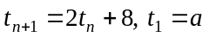 where a is a constant.

Question 3

If 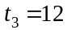, then the value of a is

- – 3
- 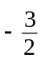
- 0
- 6
- 72

Question 4

The sequence generated by this difference equation is

- arithmetic
- constant
- geometric
- increasing
- Fibonacci related
Question 5

A container of sunscreen uses a pump to deliver the sunscreen. On the first pump it delivers 20ml of sunscreen. For each pump after that, the amount of sunscreen delivered decreases by 1%
The total amount, in ml, of sunscreen that can be delivered from this container of sunscreen is

- 200
- 200.02
- 202.02
- 2 000
- 2 200

Question 6

Tim takes up bike riding with his mates.
His first ride lasts for 20 minutes.

The time Tim spends riding on his n^{th} ride is given by the difference equation

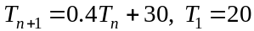.

The longest ride Tim will do, will last for

- 33 minutes
- 38 minutes
- 45 minutes
- 50 minutes
- 53 minutes

Question 7

For a geometric sequence, the first term, , is negative.
The common ratio of this sequence is positive.
A graph that could show the first five terms of this sequence is

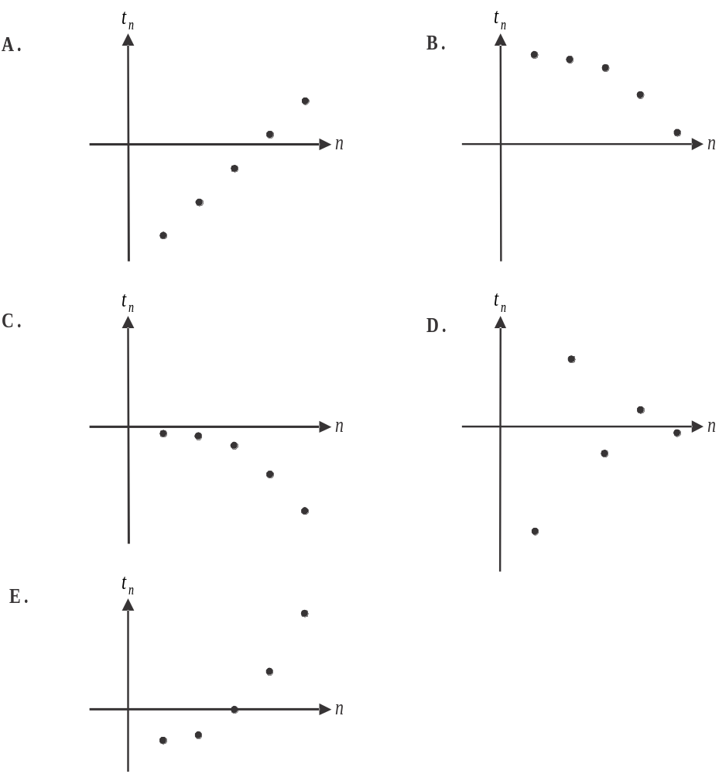

Question 8

A sports teacher places some witches hats in a straight line. The distance between successive witches hats increases according to a geometric sequence which has a common ratio of .
The distance between the first two hats is 10m and the distance between the last 2 is 17.71561m.
The distance, in metres, between the first and the last witches hat is

- 86.2138
- 89.429
- 94.87171
- 104.358881
- 114.359

Question 9

An underground fuel tank has a capacity of 10 000 litres and at the start of week 1 it is full. Each week 7% of this fuel is sold and at the end of each week 200 litres of fuel is added to the tank.
The amount of fuel, in litres, in the tank at the start of week 8 is closest to

- 1 435
- 1 765
- 6 854
- 7 478
- 7 155

Module 2: Geometry and trigonometry

If you choose this module all questions must be answered.

Question 1

A regular octagon, with centre O, is shown below.
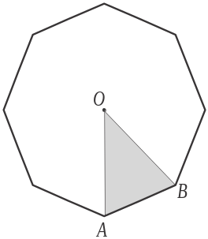

The shaded triangle ABO has an area of 5cm².
The area, in cm², of this regular octagon is

- 25
- 30
- 35
- 40
- 45

Question 2

The diagram below shows the rectangle WXYZ which has length 10 metres and width 8 metres.
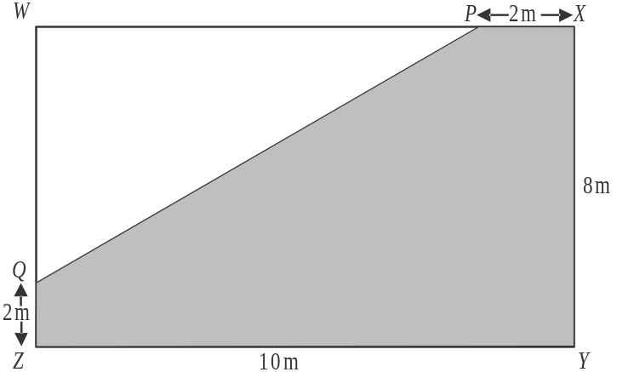

The distances PX and QZ are each 2m.
The area of the shaded region PXYZQ, in square metres, is closest to

- 24
- 48
- 56
- 62
- 78

Question 3

In triangle MNP, .

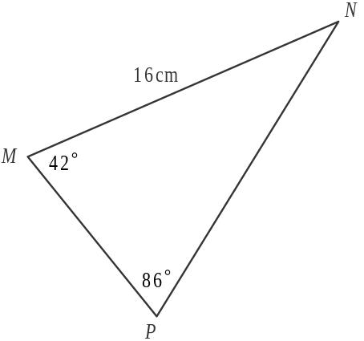

The length, in cm, of MP is closest to

- 12.58 cm
- 12.64 cm
- 13.38 cm
- 14.26 cm
- 20.25 cm

Question 4

The distance between two cities is 50km. On a map with a scale of 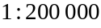, the distance between these two cities would be

- 0.04 cm
- 0.4 cm
- 4 cm
- 2.5 cm
- 25 cm

Question 5

The contour map below has contours at 20 metre intervals and the line XY is drawn on it.
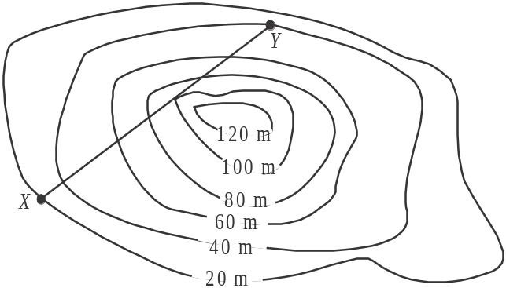

Along the line XY, the cross-section could best be represented by

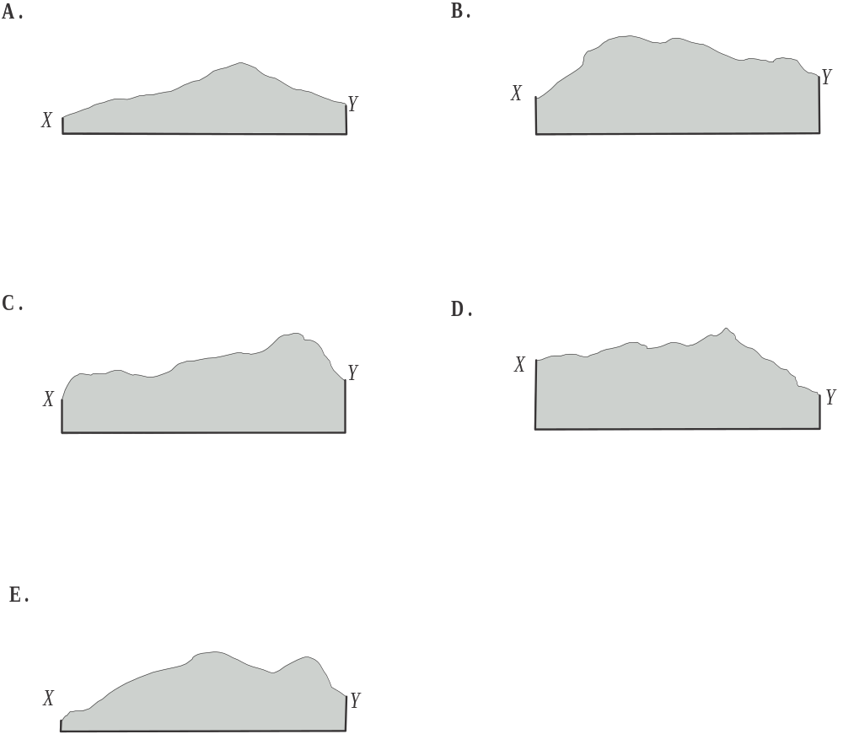

Question 6

In the parallelogram shown below, .
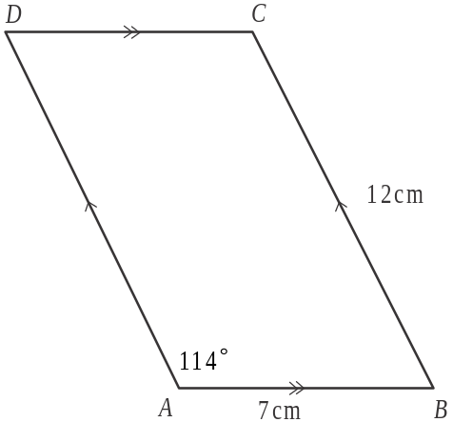

The length of the shorter diagonal of this parallelogram is closest to

- 4.0 cm
- 10.9 cm
- 11.2 cm
- 13.7 cm
- 15.0 cm

Question 7

A beer glass in the shape of a right cone with a circular base is partly filled with beer.

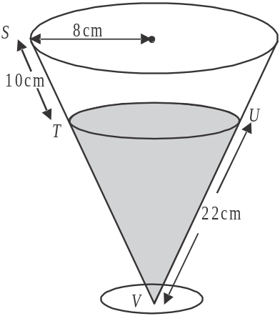

The radius of the rim of the glass is 8 cm, 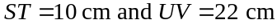.
The length TU is

- 5.5 cm
- 7.3 cm
- 9.6 cm
- 11.0 cm
- 11.6 cm

Question 8

On an outback station the shearing shed is 1 km due north of the homestead.
The cattleyard is 4 km from the shearing shed on a bearing of 130°.
The helipad is 2 km due west of the cattleyard.
The bearing of the helipad from the homestead is closest to

- 127°
- 132°
- 137°
- 141°
- 146°

Question 9

Grain is held in a container which is in the shape of a triangular prism. The cross-section of the prism includes two sidelengths of 1 metre at an angle of 50° to one another as shown.
The grain is then tipped into a skip, which is in the shape of a rectangular prism with a square cross-section with sidelengths of 1 metre.

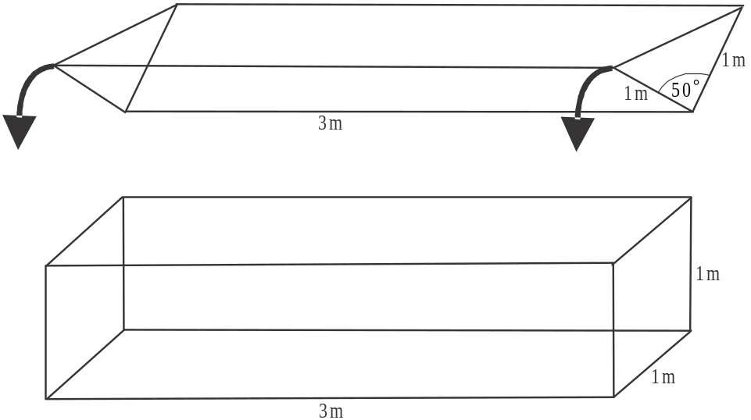

The length of both prisms is 3 metres. A full container of grain is tipped into a skip and the surface of the grain is levelled out flat. The height of the grain in the skip is closest to

- 0.13 metres
- 0.38 metres
- 0.50 metres
- 0.77 metres
- 1.0 metres

Module 3: Graphs and relations

If you choose this module all questions must be answered.

Question 1

An equation for the straight line that passes through the points 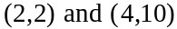 is

- 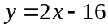
- 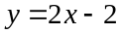
- 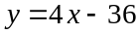
- 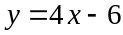
- 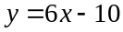

Question 2

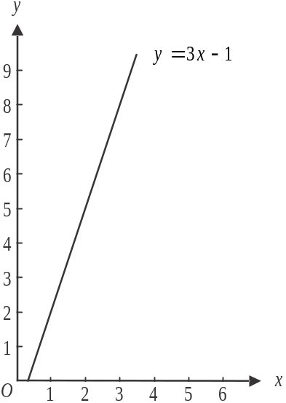

The line with equation 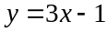 is shown on the graph above.
A point which satisfies the inequality 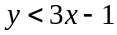 is

- 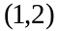
- 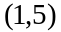
- 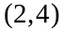
- 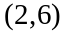
- 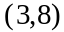
Question 3

The graph below shows the temperature, in degrees Celsius, inside an incubator over time, in hours.

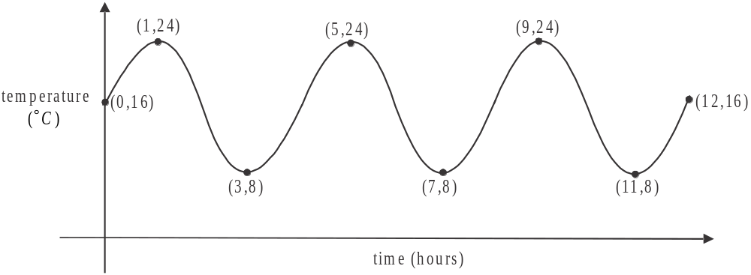

Over the time interval shown on the graph, the number of times that the temperature inside the incubator is 12° C is

- 3
- 4
- 5
- 6
- 7

Question 4

The charge, $C made by a computer technician for a home visit lasting n hours, is given by 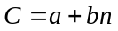.
On one job the charge was $205 for 2 hours and on another job the charge was $445 for 5 hours.
The amount b, that this technician charges per hour is

- $45
- $60
- $80
- $89
- $102.50

Question 5

The feasible region for a linear programming problem is shown as the shaded region (boundaries included) on the diagram below.

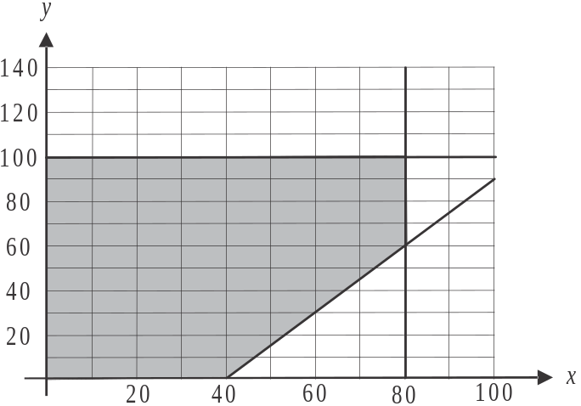

For this problem, involving capacity at a boarding kennel,

- x represents the number of small dogs at the kennel
- y represents the number of large dogs at the kennel

One of the constraints that defines the feasible region shown above, tells us that at the kennel,

- there can be no more than 40 small dogs
- there has to be 80 small dogs and 60 large dogs
- there must be no less than 60 large dogs
- the total number of dogs cannot be more than 80
- there can be no more than100 large dogs

Question 6

Six different shaped cylinders have the same volume. For each of these cylinders, the area of the base A, in cm², is plotted against where h is the height, in cm, of a cylinder.
These six data points lie on a straight line.

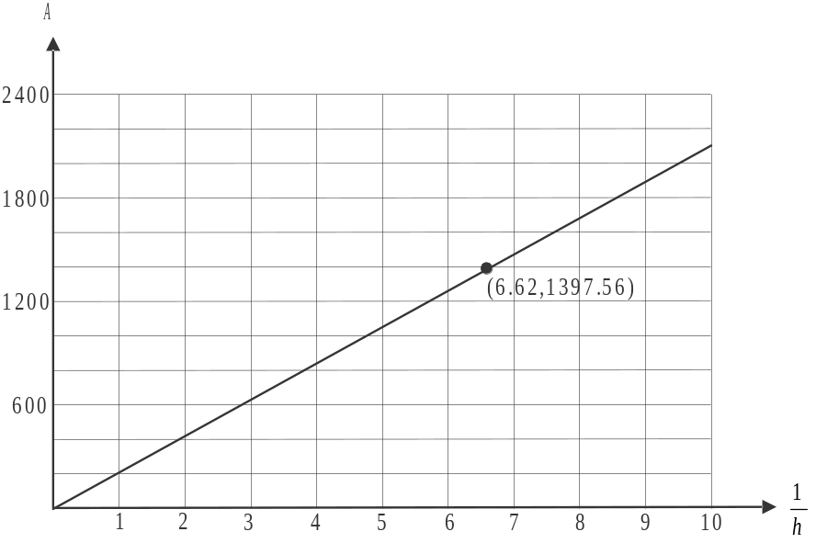

One of these data points is the point 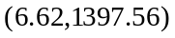.
The rule that relates the area of the base of a cylinder, A, to the height of the cylinder, h, is

- 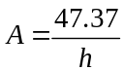
- 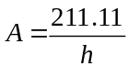
- 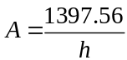

Question 7

Two supplements, A and B contain a certain substance.
There are 2g of the substance in each tablet of supplement A and 5g of the substance in each tablet of substance B. An athlete aims to have a minimum of 12g of the substance each day.
Let x be the number of tablets of supplement A taken by the athlete each day.
Let y be the number of tablets of supplement B taken by the athlete each day.
Assume that the athlete can’t obtain this substance other than by taking supplement A and B.
This situation can be represented by the inequality

- 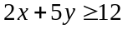
- 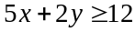
- 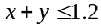
- 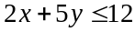
- 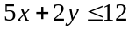
Question 8

At a market, Pat sells her first 100 pots of jam for $5 each. She sells her remaining pots of jam for $4 each.
The revenue, R, in dollars that Pat makes for selling n pots of jam is given by

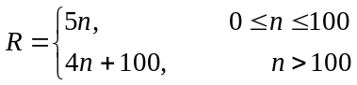

Pat’s costs, C, in dollars, in making the n pots of jam is given by 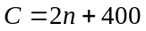.

If Pat is to break even, then the number of pots of jam she must sell is

- 100
- 133
- 150
- 200
- 500

Question 9

On the graph below, the shaded region (including boundaries) represents the feasible region in a linear programming problem.
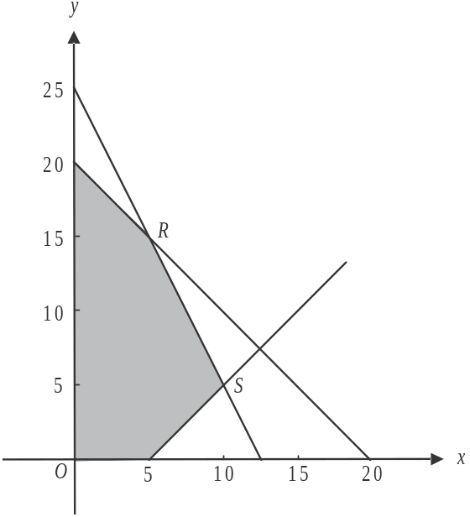

The maximum value of the objective function 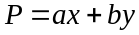 occurs at the vertices R and S.
The values of a and b could be

Module 4: Business-related mathematics

If you choose this module all questions must be answered.

Question 1

A consultant charges $250 per hour for her services. She adds a Goods and Services Tax (GST) of 10% to her charge. The total charge, including GST, for a client who engaged the consultant for five hours would be

- $25.00
- $125.00
- $1 275.00
- $1287.50
- $1 375.00

Question 2

Rita bought a new oven priced at $1 499 on a hire purchase plan. She paid a deposit and then made equal quarterly payments for three years. The flat interest rate she was charged per annum under this plan was 8.1%. The effective interest rate per annum that Rita paid was closest to

- 13%
- 15%
- 16%
- 18%
- 21%

Question 3

$12 000 is invested at a simple interest rate of 5.2% per annum. At the end of the investment period, the investment is worth $12 312. The number of years that the money was invested for was

- 0.5
- 1
- 1.5
- 2
- 3

Question 4

The attendance in 2010 at a major sporting event, held annually, was 98 500. In 2011 there was a decrease of 10% on this figure. In 2012 there was an increase of 10% on the 2011 attendance figure. The attendance at this sporting event in 2012 can be found by calculating

- 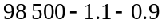
- 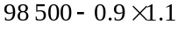
- 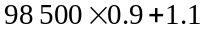
- 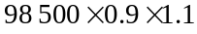

Question 5

The annual turnover for an online retail business increased by 15% each year over the period 2011 – 2013. In 2013 the annual turnover was $176 000.
In 2011, the annual turnover for the business was closest to

- $123 050
- $127 160
- $133 081
- $202 400
- $232 760

Question 6

Sam invests $2 000. The value of his investment over a five year period is shown below.

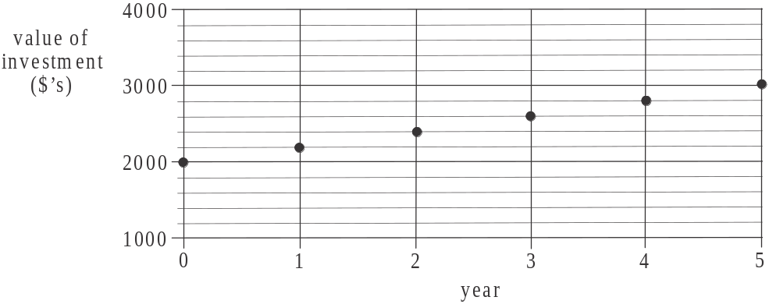

Jane makes an investment under the same conditions as Sam.
After 12 years, Jane has earned a total of $3 840 in interest.
The amount Jane invested was

- $1 600
- $2 400
- $3 200
- $4 608
- $6 400

Question 7

Bhavani invests $80 000 in an annuity that will pay her a monthly amount of $860 for 10 years. The annual interest rate for this annuity is closest to

- 1.1%
- 2.9%
- 3.4%
- 5.3%
- 6.2%

Question 8

Marita took out a reducing balance loan for $210 000 at an interest rate of 8.26% per annum compounding quarterly. She will make equal quarterly payments of $10 225.
Which one of the following statements is true?

- Marita will have fully paid out the loan in less than six years.
- After three years, Marita will still owe more than $135 000 on the loan.
- Marita could halve the time it takes to fully pay out the loan if her repayments were $15 000 per quarter rather than $10 225 per quarter.
- The amount of interest included in Marita’s first payment is less than $4 500.
- With each payment Marita makes, the amount she pays off the principle decreases and the amount she pays in interest increases.

Question 9

Jason invests $15 000 for 3 years. He receives interest at the rate of 6.8% per annum compounding each six months.
The interest Jason receives in the third year of this investment is given by

- 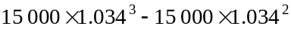
- 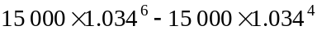
- 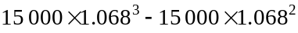
- 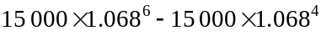
- 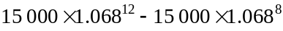
Module 5: Networks and decision mathematics

If you choose this module all questions must be answered.

Question 1

Which one of the following is a simple graph?

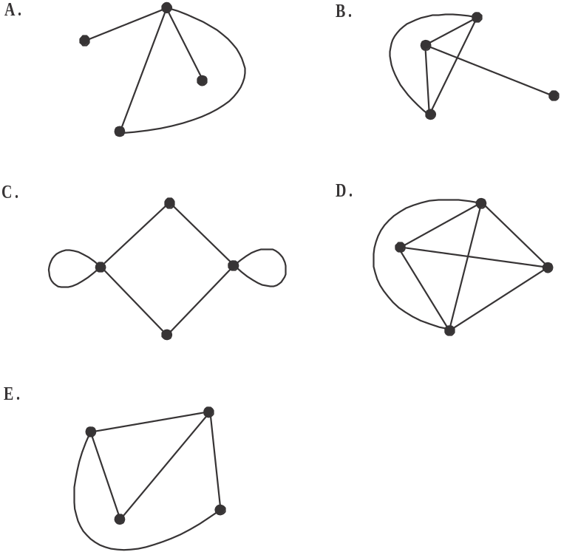

Question 2

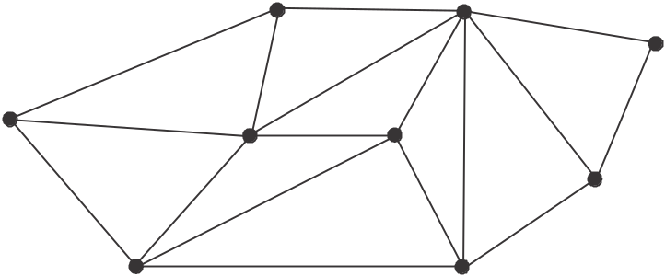

A spanning tree for the graph shown above would have

- 6 edges
- 7 edges
- 8 edges
- 9 edges
- 10 edges

Question 3
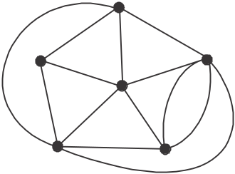

A planar graph is shown above. The number of faces it has is

- 6
- 9
- 11
- 13
- 15

Question 4
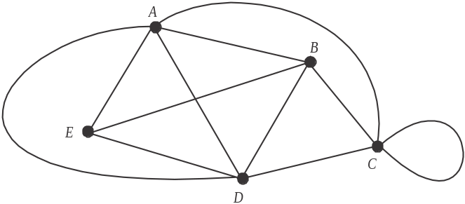

The adjacency matrix for the graph shown above is
- 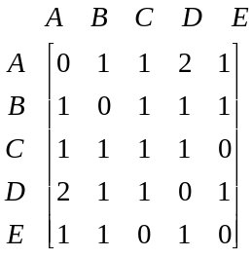
- 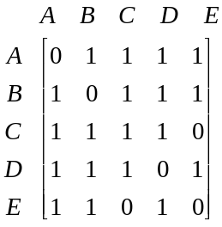
- 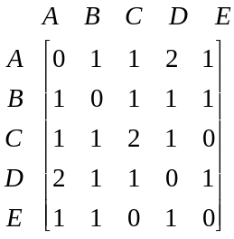
- 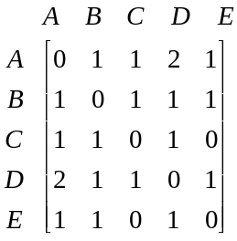

- 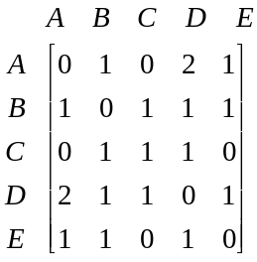

Question 5

Four friends, Dave, Hui, Kiran and Tom, run a car cleaning business during their vacation. There are four tasks A, B, C and D involved in cleaning each car and the fastest time, in minutes, that the boys can complete each of the tasks is shown in the table below.

 | Dave | Hui | Kiran | Tom
A | 4 | 4 | 2 | 2
B | 4 | 6 | 5 | 3
C | 2 | 3 | 2 | 4
D | 5 | 3 | 6 | 2

Given that each of the boys is allocated just one task, the minimum time in which they can clean a car is

- 8 minutes
- 9 minutes
- 10 minutes
- 11 minutes
- 12 minutes

Question 6

For the directed graph below, every vertex can be reached from every other vertex.

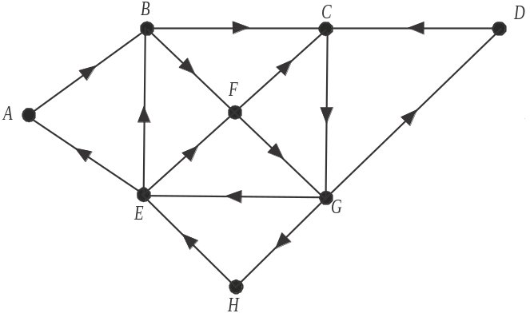

Which one of the following edges could be removed so that every vertex could still be reached from every other vertex?

- A to B
- D to C
- C to G
- G to E
- G to H

Question 7

The network below shows the time (in weeks) that it takes to complete each of the 11 activities A – K that form a building project.

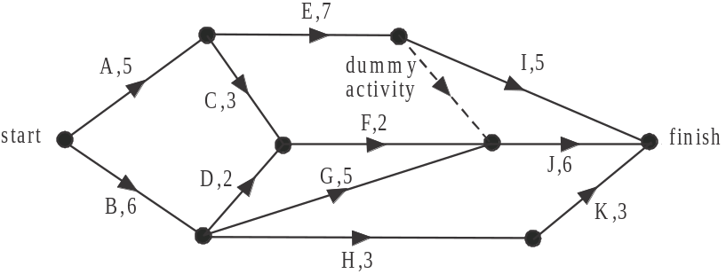

The critical path for this building project is

- A, E, J
- A, E, I
- B, G, J
- B, H, K
- A, C, F, J

Question 8

The different heights of five cousins, Matt, Jarrod, Ayce, Harry and Ari are noted at a family function.
The graph below shows the relationship between some of the cousins in terms of their heights. The arrow from Matt to Ayce, for example, indicates that Matt is taller than Ayce.

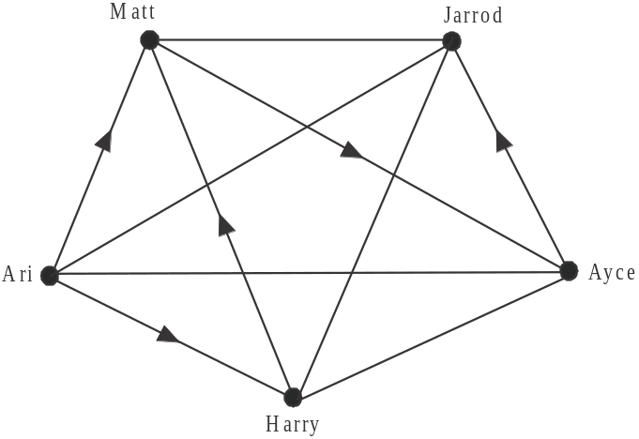

The third tallest of the cousins is

- Matt
- Jarrod
- Ayce
- Harry
- Ari

Question 9

The paths connecting the three entrances W, E and N, in a suburban park are shown on the map below.

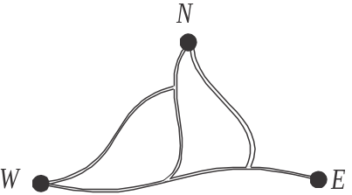

A graph that shows all the different routes between the entrances is

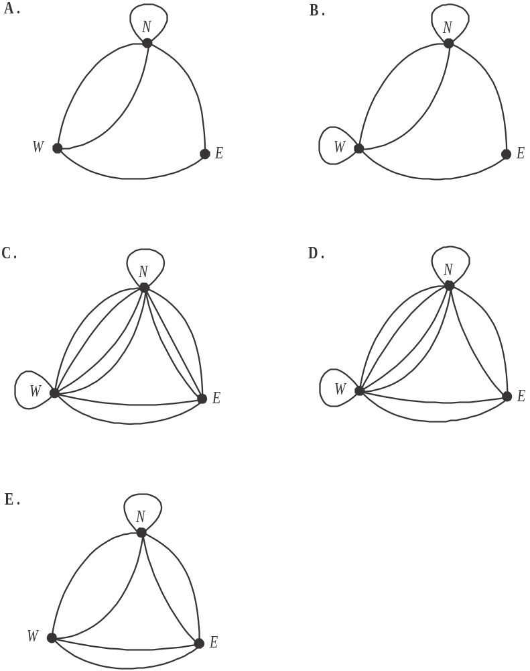

Module 6: Matrices

If you choose this module all questions must be answered.

Question 1

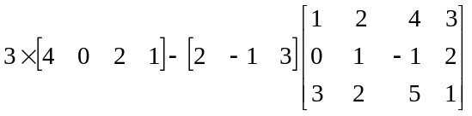 is equal to

- 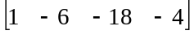
- 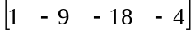
- 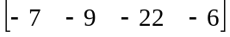
- 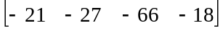
- 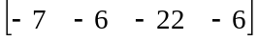

Question 2

George filled his car with petrol and filled his partner’s car with diesel.
The cost, in dollars, of a litre of petrol (P) and a litre of diesel (D) is shown by matrix C where

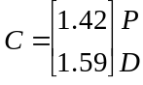

The number of litres of petrol and diesel he purchased is shown by matrix L where

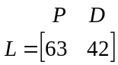

The matrix product LC

- is not defined
- gives the total number of litres of fuel purchased
- give the total number of litres of fuel purchased and the total amount paid
- gives the total amount paid
- the number of litres of petrol purchased, the number of litres of diesel purchased and the respective costs of these two purchases.

Question 3

A set of simultaneous equations is given below.

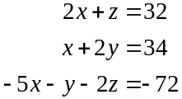

The solution for this set is given by
- 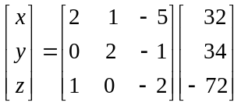
- 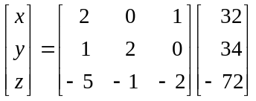

- 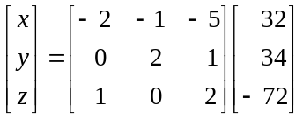
- 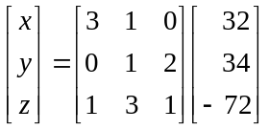

- 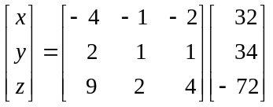

Question 4

The 132 VCE students at Riverdale College can either go to the library (L), the common room (C) or to an empty classroom (E) during their free periods.
Students have one free period each day and their choice from one day to the next is given by the transition matrix T below.

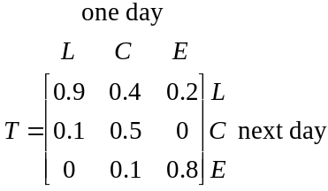

On the first day of school, 74 students went to the library, 38 went to the common room and 20 went to an empty classroom.
Over the long term, the number of students (expressed to the nearest whole number) expected to go to the common room is

- 10
- 20
- 26
- 86
- 101

Question 5

Four siblings, Anita (A), Kate (K), Sue (S) and Tom (T) were asked whether they liked or disliked each of the six vegetables, broccoli (B), corn (C), eggplant (E), mushrooms (M), peas (P) and zucchini (Z).
Their replies are shown in the table below.

Vegetable | Sibling
Vegetable | Anita (A) | Kate (K) | Sue (S) | Tom (T)
broccoli (B) | like | dislike | like | like
corn (C) | like | like | like | dislike
eggplant (E) | dislike | like | dislike | dislike
mushrooms (M) | dislike | like | like | like
peas (P) | like | like | dislike | dislike
zucchini (Z) | like | dislike | dislike | like

A matrix is to be used to represent this information where a 1 indicates that a sibling likes a specific vegetable and a 0 indicates that a sibling dislikes a specific vegetable.
That matrix could be given by

- 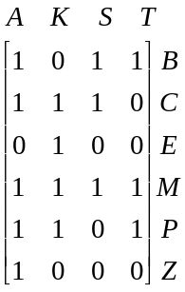
- 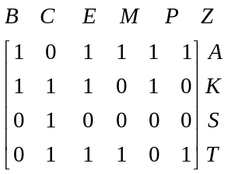
- 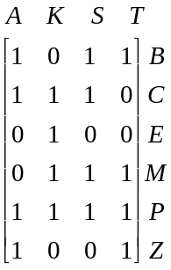

- 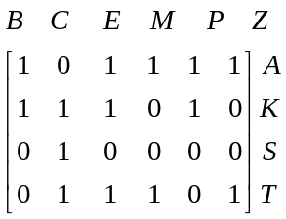

- 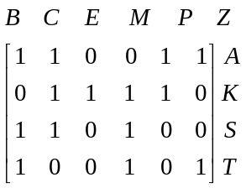

Question 6

A factory outlet sells dresses for $40 and tops for $25.
For one day, the dresses only, are discounted by 20%.
A column matrix that gives the prices, in dollars, of dresses and tops on this day can be found by calculating

- 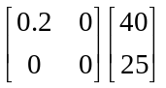

- 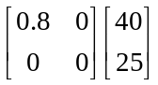

- 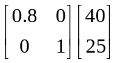

- 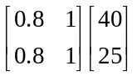

- 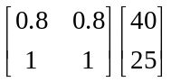

Question 7

The matrix A is given below

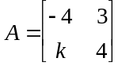

For a particular value of k, the matrix A is equal to its inverse, 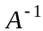. That value of k is

- – 5
- – 4
- – 3
- 4
- 5
Question 8

A retail store has one duty manager for the day, during opening hours. The store is open seven days a week.
Four people, Bhavani (B), Clinton (C), Doug (D) and Emma (E) can perform this role.
The roster, from day to day, is determined by the transition matrix below.

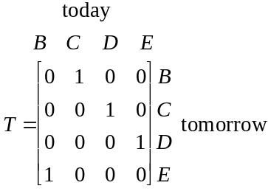

On Monday, Doug was duty manager. Which one of the following statements is true?

- Doug is always duty manager the day after Bhavani is.
- Over a 28 day period, Bhavani is duty manager more often than Emma.
- Emma is duty manager the following Monday.
- Doug is not on duty again until the following Thursday.
- Clinton is always duty manager the day after Emma is.

Question 9

For the matrices A, B, C and X, the matrix is defined. The matrix expressions 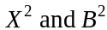 are also defined but is not defined.
Which one of the following expressions involving these matrices is defined?

- 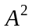
- 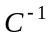
- BA
- CX

Further Mathematics Formulas

Core: Data analysis

standardised score: 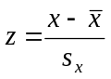
least squares line: 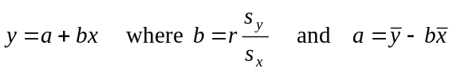
residual value: residual value = actual value – predicted value

seasonal index: seasonal index 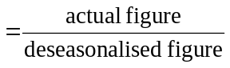

Module 1: Number patterns

arithmetic series: 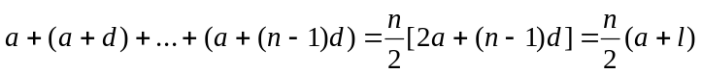
geometric series: 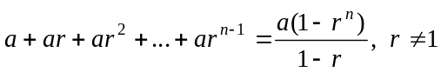
infinite geometric series: 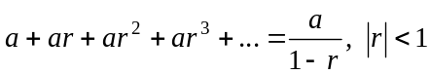

Module 2: Geometry and trigonometry

area of a triangle: 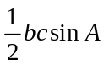
Heron's formula: 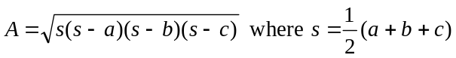
circumference of a circle: 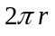

area of a circle: 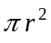

volume of a sphere: 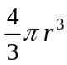
surface area of a sphere: 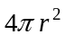

volume of a cone: 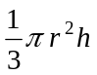
volume of a cylinder: 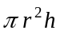

volume of a prism: 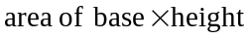
volume of a pyramid: 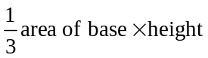

Mathematics Formula Sheets reproduced by permission; © VCAA 2013. The VCAA does not endorse or make any warranties regarding this study resource. Current and past VCAA VCE® exams and related content can be accessed directly at www.vcaa.vic.edu.au
Pythagoras’ theorem 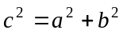

sine rule: 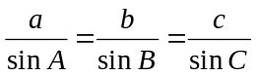
cosine rule: 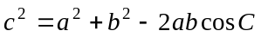

Module 3: Graphs and relations

Straight line graphs
gradient (slope): 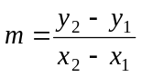
equation: 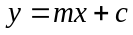

Module 4: Business-related mathematics

simple interest: 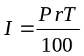
compound interest: 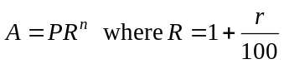
hire purchase: 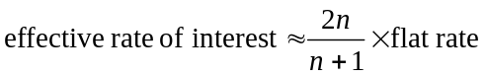

Module 5: Networks and decision mathematics

Euler’s formula: 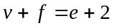

Module 6: Matrices

determinant of a 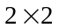 matrix 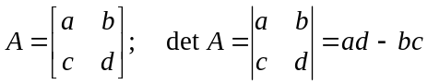
inverse of a matrix 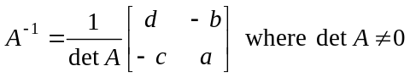

END OF FORMULA SHEET

